|  |  |
| --- | --- |
| **Jira ID:**  NEXG-1391 | **JIRA Ticket Description:**  Reports > Forms Count Summary Changes   * Change column heading Unique Submissions to Unique Contacts * Overall Submissions should show ALL the submissions, not just the Contacts. * Overall Submissions should have Eyeball details icon view beside the number * When Eyeball details is selected, pop up a display that shows the Form Submission Details for each entry (see attached S/S from Classic for an example.)   NEW SCOPE ADDED:   * Click through to details for each Form * Show Contact Name, all form details and be able to Export all data with date range and other defined filters.   **Sign off document Description:**  Technical Design Details:   * Overall Submissions should show ALL the submissions, not just the Contacts. * Overall Submissions should have Eyeball details icon view beside the number * When Eyeball details is selected, pop up a display that shows the Form Submission Details for each entry (see attached S/S from Classic for an example.) * Click through to details for each Form * Show Contact Name, all form details and be able to Export all data with date range and other defined filters.   Review Notes & Additional Details:   * Must show repeated submissions as this is Overall and not Unique * Eyeball view should take User to Advanced View and NOT the standard Contacts Grid * Advanced View to display the specific columns related to the report First Name, Last Name, Email Address, Phone, Form Name, Lead Source, Lead Source Date   Note: Eyeball Click in both the above screens (Reports or Forms Grid) will take users to Contacts Advance View Grid. On click of eyeball on this screen will take user to form details screen. |
| Resource | Siva |
| Revision Version | V.1 |
| Last Revised Date | 03/28/2016 |

Impact analysis

|  |  |
| --- | --- |
| **Module Name** | **Impact Score – 1-10** |
| Reports- Advanced view page is shared by different reports. The eye icon should be visible only for Forms Report. This may impact the other reports. | 1 |

Database Design

|  |  |
| --- | --- |
| **Object – SP/Table/View/Function etc** | **Impact** |
|  |  |
|  |  |
|  |  |

Application Design

|  |  |
| --- | --- |
| **New Objects – View/Controller/Attribute etc** | **Impact** |
|  |  |
|  |  |

Entitlements

|  |  |
| --- | --- |
| **Module/View/Requirement** |  |
| None | None |
|  |  |
|  |  |

Comments

|  |  |  |
| --- | --- | --- |
| Reviewed By | Comments | Date |
|  |  |  |
|  |  |  |
|  |  |  |

|  |  |
| --- | --- |
| Approved By | <Name> |
| Approved On | <Date> |

Deviations from the signed off document that Tammy Uploaded on 28/03/2016:

**Technical Design Details:**

1. Overall Submissions should show ALL the submissions, not just the Contacts. We will not be showing all the submissions. We will show only the unique contacts since we are redirecting to the Advanced view page.
2. Overall Submissions should have Eyeball details icon view beside the number.
3. When Eyeball details is selected, pop up a display that shows the Form Submission Details for each entry (see attached S/S from Classic for an example.). We will show only the unique contacts since we are redirecting to the Advanced view page.
4. Click through to details for each Form. Since, the user will be in the Advanced View Page, when clicked we will navigate to the contact detail page.
5. Show Contact Name, all form details and be able to Export all data with date range and other defined filters. The Advanced View Page already have the export feature. But, we need to populate this grid with the fields selected for the form.

**Review Notes & Additional Details:**

* Must show repeated submissions as this is Overall and not Unique. We will not showing all the submissions. We will show only the unique contacts since we are redirecting to the Advanced view page.
* Eyeball view should take User to Advanced View and NOT the standard Contacts Grid.
* Advanced View to display the specific columns related to the report First Name, Last Name, Email Address, Phone, Form Name, Lead Source, Lead Source Date. Form name cannot be shown because it is not a property of contact object. And we will show the fields that the form has.

**Moqups: Grid Changes**

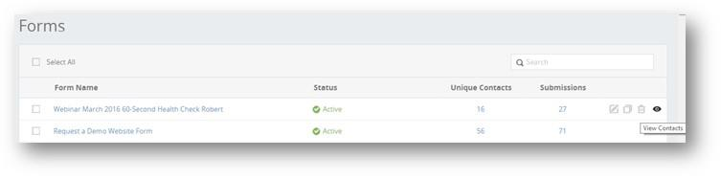

**Report Changes**

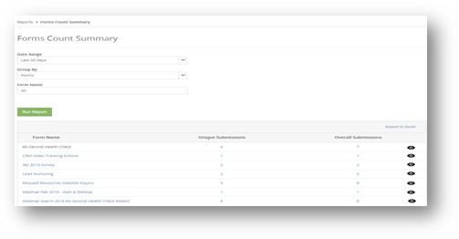

**Advance Contacts View Grid**

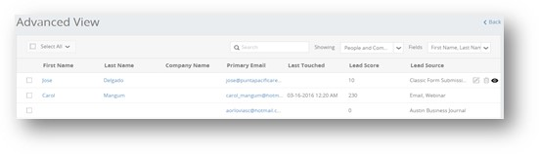

**Note:**Eyeball Click in both the above screens (Reports or Forms Grid) will take users to Contacts Advance View Grid.

On click of eyeball on this screen will take user to form details screen. This will always show the contact’s latest submission compared to its previous values.

**Pop-up Form Details Screen from Advance Contact View Grid:**

